Course Plan: Chemistry 11 (Blended)
Teacher: Ms. Logan-Goyette
Course URL: | http://langley.lambdasolutionscloud.net/
Insert your Username & Password and click Login.  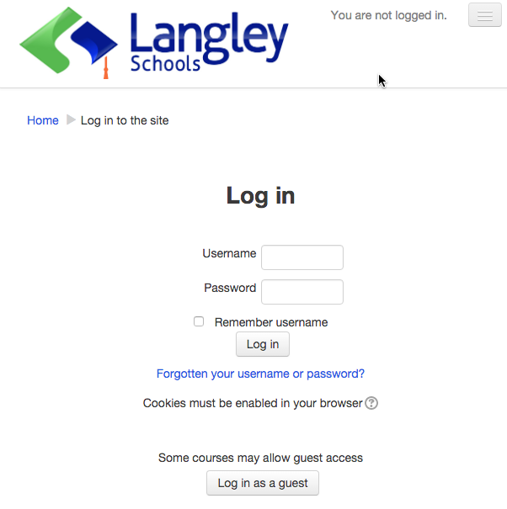  Keep your log in information in a safe & private place. Please let you teacher know immediately if you suspect someone knows you log in information and may have access to your course(s). |  | Find your course in the list. Click on the title.  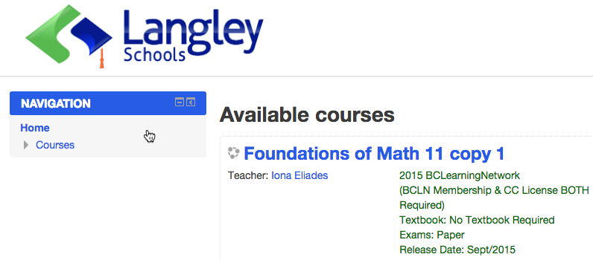
User Name & Password: | User Name:  Password:  Keep your log in information in a safe & private place. Please let you teacher know immediately if you suspect someone knows you log in information and may have access to your course(s).
My Classes: | In the Classes area, you will see the title of your course(s).  Click on the title of the course you would like to start.
Log Out: | Always be sure to click Log out when you are finished working on your courses.
Course Description: | The Chemistry 11 course involves studying the nature of matter, atomic theory, the mole concept, chemical reactions, solution chemistry as well as organic chemistry. This course will give you the basis to continue on into chemistry 12 and chemistry courses in post-secondary studies.
Course Outline: | Unit Topic & Subtopics Assignments, Projects and Exams  1 Introduction to Chemistry Unit 1 Learning Guide  The Scientific Method Project 1: Density Graphing Lab Project 1 Choice: Household Measurements Unit 1 Exam  Scientific Notation and Significant Figures  The International System of Units  Lab Safety and WHMIS  Dimensional Analysis  Density, Graphs and Slope  Matter  Mixtures  2 Atoms Theory Unit 2 Learning Guide  History of Elements and Compounds Project 2 Choice A: Loopy Lewis Structures Project 2 Choice B: Element Properties Unit 2 Exam  The Periodic Table  Atoms, Molecules and Ions Classification  Isotopes  Bohr & Quantum Theory  Lewis Diagrams  3 Naming Compounds Unit 3 Learning Guide  Combining Capacity & Naming Compounds Project 3 Choice A: Ionic Puzzle Pieces Project 3 Choice B: Household Chemicals Unit 3 Exam  Writing the Formula of a Compound  Multivalent Metals and Polyatomic Ions  Names and Formulas of Acids  4 The Mole Concept Unit 4 Learning Guide  The Mole Project 4 Choice A: Pancake Particles and the Molar Meal Project 4 Choice B: Magnesium Oxide Lab Unit 4 Exam  Molar Mass and Compounds  Characteristics & Molar Volume of Gases  Percent Composition  Empirical Formula  Molecular Formula  Molar Concentration  Solutions and Dilutions  5 Chemical Reactions Unit 5 Learning Guide  Chemical Equations Project 5 Choice A: Reactions Rebus Project 5 Choice B: Endothermic and Exothermic Reactions Unit 5 Exam  Balancing Equations  Types of Chemical Reactions  Energy  Stoichiometry  Limiting Reagents  6 Solution Chemistry Unit 6 Learning Guide  Mixtures and Solutions Project 6 Choice A: Solutions Simulation Project 6 Choice B: Dissociation Dilemmas Unit 6 Exam  Molar Concentration  Polarity in Molecules  Dissociation Ionic Equations  Electrolytes  Chemical Reactions and Solutions  7 Organic Chemistry Unit 7 Learning Guide  Organic Chemistry Project 7 Choice A: Classes of Organic Compounds Project 7 Choice B: Molecular Models Unit 7 Exam  Alkanes  Structural Representation  Isomers of Alkanes  Naming Organic Compounds  Naming and Drawing Alkenes  Alkynes and Cycloalkanes  Drawing and Naming Alcohols  Hydrocarbon Derivatives and Synthesis  Units 1 – 7 Final Exam
Key Learning Outcomes: | Students will meet the required learning outcomes for this course which include some of the following key learning outcomes:  - Apply ethical standards with respect to privacy, confidentiality, piracy, plagiarism, and personal behavior while using electronic tools to gather information  - Demonstrate strategies that protect personal privacy while using the Internet  - Show respect for the opinions and contributions of others while participating in or leading teams  - Organize information from a variety of sources, using computer software, for various audiences and purposes  - Apply the principles of distributed learning in a web-based learning environment  - Evaluate online learning tools  - Evaluate different types of personal computing/digital devices that could be used for educational purposes.  - demonstrate appropriate safety techniques and proper use of protective equipment  - demonstrate skills in measuring, in recording data and in communicating results  - relate the observable properties and characteristics of elements, compounds, and mixtures  to the concept of atoms and molecules  - write the names and formulae for ionic and covalent compounds, given appropriate charts  or data tables  - describe the characteristics of matter  - differentiate between physical and chemical changes  - explain the significance and use of the mole  - perform calculations involving the mole and molarity  - perform calculations involving molecular and empirical formulae to identify a substance  - describe concentration in terms of molarity  - explain chemical reactions in terms of the rearrangement of the atoms as bonds are broken and  new bonds are formed  - apply the law of conservation of mass to balance formula equations  - devise balanced equations for various chemical reactions  - describe reactions in terms of energy changes  - perform stoichiometric calculations involving chemical reactions  - describe the development of the model of the atom  - describe the sub-atomic structures of atoms, ions, and isotopes, using calculation where appropriate  - describe the development of the modern periodic table and draw conclusions about the similarities and trends in the properties of elements, with reference to the periodic table  - justify chemical and physical properties in terms of electron population  - demonstrate knowledge of various types of chemical bonding and apply understanding of bonding to create formulae and Lewis structures  - distinguish between a solution and a pure substance  - predict the relative solubility of a solute in a solvent, based on its polarity  - calculate the concentration of ions in solution  - describe characteristic features and common applications of organic chemistry  - demonstrate knowledge of the various ways that carbon and hydrogen can combine to form a wide range of compounds  - generate names and structures for simple organic compounds  - differentiate the various types of bonding between carbon atoms
Resources: | - There is NO textbook required for this course.  - An optional extra resource for this course is: Hebden: Chemistry 11 A Workbook for Students,  ISBN 0-9682069-1-3  - You will also need the following items in order to complete this course:  a basic scientific calculator, a ruler, practice paper (lined and blank), graph paper (1cm x 1cm grid is preferred)
Assessment: | Learning Guides Projects Unit Exams Final Exam 10% 40% 20% 30%  A = 100-86%, B = 85-73%, C+ = 72-67%, C = 66-60%, C- = 59-50%, F = 49-0%  Learning Guides: Assessed for completion and work (detail) shown for practice questions.  Project Instructions: This course allows for you to choose projects that best suit your interests and/or study-needs. For each unit, you need to submit at least 1 project.
Expectations & Responsibilities: | - You are expected to:  - attend class each week (Mondays and Tuesdays). If you are unable to attend a class, you must contact your teacher.  - log on to your course and check for updates several times a week. This includes checking (and contributing to when required) your email, announcements, and discussions.  - participate in online discussions and blogs (posts & comments) each week.  - engage in conversations both in class and online.  - work collaboratively with others in class and online  - complete weekly assignments and submit them on time.  - actively work through each lesson, trying examples and reflecting on material.  - use the Learning Guide as your tool for documenting your understanding. Lay it out neatly and well organized.  - make sure you understand any quiz/exam question you get wrong. If you can't figure it out - ASK!  - be sure to use your Moodle message system for regular communication with your teacher  - If at any time you are concerned about your success in this course, or are considering dropping out of this course, please contact your teacher immediately! Your teacher can help you to reassess your commitment and progress, and help you to be successful.
Acceptable Use Policy | I understand the School District has an Acceptable Use Policy for technology and that I will be using technology for educational purposes. I also understand that due to the nature of some online technologies being hosted world-wide, it is possible that my Full Name, Student ID, School Name, email and classwork may be stored on premises outside Canada. I am aware that in such cases, Privacy laws of the country hosting the data may apply. I consent to using such online technologies in the manner prescribed by School District #35. I have read and accept the Terms and Conditions of the policy posted at Http://www.sd35.bc.ca/aup  I agree that school computers are for school use only and not for business use, illegal activity, nor are they for downloads. Anything I do on a school device is neither private nor confidential and can be tracked or traced.
Teacher Contact Information: | I understand that if I am having any difficulties with my course, I can contact my teacher as follows:  - Teacher: Ms. Logan-Goyette  - Email: rlogan-goyette@sd35.bc.ca

I have read and understand the requirements of this course. This course fulfills one of the requirements of my grad plan.

Student’s Name (Please print) :
Student’s Signature:
Office Use Only  Computer Processed | Date:

