Course Plan: Physics 11 (Online)
Teacher: Ms. Logan-Goyette
Course URL: | http://langley.lambdasolutionscloud.net/
Insert your Username & Password and click Login.  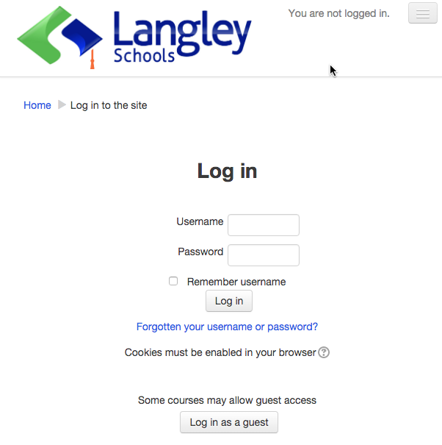  Keep your log in information in a safe & private place. Please let you teacher know immediately if you suspect someone knows you log in information and may have access to your course(s). |  | Find your course in the list. Click on the title.  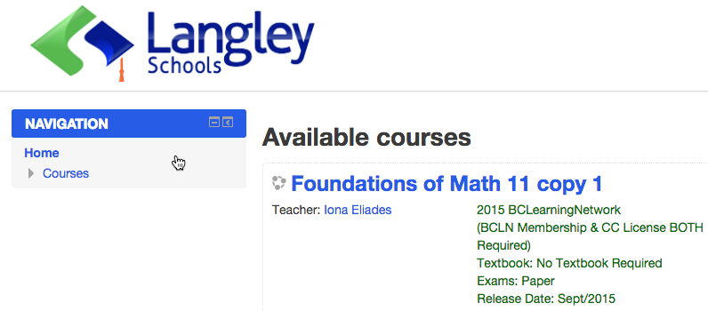
User Name & Password: | User Name:  Password:  Keep your log in information in a safe & private place. Please let you teacher know immediately if you suspect someone knows you log in information and may have access to your course(s).
My Classes: | In the Classes area, you will see the title of your course(s).  Click on the title of the course you would like to start.
Log Out: | Always be sure to click Log out when you are finished working on your courses.
Course Description: | Physics 11 introduces students to wave motion & optics, kinematics, forces, Newton’s laws, momentum, energy, special relativity as well as nuclear fission and fusion.
Course Outline: | Unit Topic Projects Assignment, Quizzes and Exams  1 Math Tools Unit 1 Project: Graph Match Unit 1 Choice Project: Vector Simulation Unit 1 Learning Guide Math Quiz 1 Math Quiz 2 Math Quiz 3 Unit 1 Exam  2 Kinematics Unit 2 Project Choices: Freefall Analysis Moving Truck Ramp & Roll Moving Person Projectile Surveying Ranking Tasks Unit 2 Learning Guide 1DKin Quiz 1 1DKin Quiz 2 1DKin Quiz 3 Unit 2 Exam  3 Projectiles Unit 3 Project Choices: Projectile Launch Projectile Motion Exploration Water Pistol Projectile Elephant Jump – Real or Fake? Ranking Tasks Unit 3 Learning Guide 2DKin Quiz 1 2DKin Quiz 2 2DKin Quiz 3 Unit 3 Exam  4 Dynamics Unit 4 Project Choices: Newton’s Second Law Atwood’s Machine Dynamics Forensics Hooke’s Law General Dynamics Newton’s Law Comic Strip Ranking Tasks Unit 4 Learning Guide Dynam Quiz 1 Dynam Quiz 2 Dynam Quiz 3 Unit 4 Exam  5 Momentum Unit 5 Project Choices: Impulse Lab Exploding Carts 1D Collisions Lab Ranking Tasks Unit 5 Learning Guide Mom Quiz 1 Mom Quiz 2 Mom Quiz 3 Unit 5 Exam  6 Energy Unit 6 Project Choices: Power of Toy Energy of Pole Vault Hot Wheels Efficiency Appliance Efficiency Skate Park Energy Ranking Tasks Unit 6 Learning Guide Energy Quiz 1 Energy Quiz 2 Energy Quiz 3 Unit 6 Exam  7 Waves & Light Unit 7 Project Choices: Standing Waves Wave on a String Snell’s Law Magnifying Glass Optics Optics Lab Ranking Tasks Unit 7 Learning Guide Waves Quiz 1 Waves Quiz 2 Waves Quiz 3 Unit 7 Exam  8 Electric Circuits Unit 8 Projects: Build Circuits to Specification Parallel Circuit Challenge Terminal Voltage Lab Circuits Dissection Ranking Tasks Unit 8 Learning Guide Circuits Quiz 1 Circuits Quiz 2 Circuits Quiz 3 Unit 8 Exam  Unit 1 - 9 Final Exam
Key Learning Outcomes: | Students will meet the required learning outcomes for this course which include some of the following key learning outcomes:  - Apply ethical standards with respect to privacy, confidentiality, piracy, plagiarism, and personal behavior while using electronic tools to gather information  - Demonstrate strategies that protect personal privacy while using the Internet  - Show respect for the opinions and contributions of others while participating in or leading teams  - Organize information from a variety of sources, using computer software, for various audiences and purposes  - Apply the principles of distributed learning in a web-based learning environment  - Evaluate online learning tools  - Evaluate different types of personal computing/digital devices that could be used for educational purposes.  - describe the nature of physics and apply the skills and methods of physics  - analyse the behaviour of light and other waves under various conditions, with reference to the properties of waves and using the universal wave equation  - use ray diagrams to analyse situations in which light reflects from plane and curved mirrors  - analyse situations in which light is refracted  - apply knowledge of the relationships between time, displacement, distance, velocity, and speed to situations involving objects in one dimension  - apply knowledge of the relationships between time, velocity, displacement, and acceleration to situations involving objects in one dimension  - forces  - solve problems involving the force of gravity  - analyse situations involving the force due to friction  - apply Hooke’s law to the deformation of materials  - solve problems that involve application of Newton’s laws of motion in one dimension  - apply the concept of momentum in one dimension  - perform calculations involving work, force, and displacement  - solve problems involving different forms of energy  - analyse the relationship between work and energy, with reference to the law of conservation of energy  - solve problems involving power and efficiency  - explain the fundamental principles of special relativity  - analyse nuclear processes
Resources: | - There is NO textbook required for this course.  - You do need a basic scientific calculator.
Assessment: | Quizzes Learning Guides Projects Unit Exams Final Exam 10% 10% 40% 20% 20%  A = 100-86%, B = 85-73%, C+ = 72-67%, C = 66-60%, C- = 59-50%, F = 49-0%  Learning Guides: Assessed for completion and work (detail) shown for practice questions.  Project Instructions: This course allows for you to choose projects that best suit your interests and/or study-needs. For every two units, you can choose from the listed projects. You may submit more than one to total 25 credits.
Expectations & Responsibilities: | - You are expected to:  - attend class each week (Mondays and Tuesdays). If you are unable to attend a class, you must contact your teacher.  - log on to your course and check for updates several times a week. This includes checking (and contributing to when required) your email, announcements, and discussions.  - participate in online discussions and blogs (posts & comments) each week.  - engage in conversations both in class and online.  - work collaboratively with others in class and online  - complete weekly assignments and submit them on time.  - actively work through each lesson, trying examples and reflecting on material.  - use the Learning Guide as your tool for documenting your understanding. Lay it out neatly and well organized.  - make sure you understand any quiz/exam question you get wrong. If you can't figure it out - ASK!  - be sure to use your Moodle message system for regular communication with your teacher  - If at any time you are concerned about your success in this course, or are considering dropping out of this course, please contact your teacher immediately! Your teacher can help you to reassess your commitment and progress, and help you to be successful.
Acceptable Use Policy | I understand the School District has an Acceptable Use Policy for technology and that I will be using technology for educational purposes. I also understand that due to the nature of some online technologies being hosted world-wide, it is possible that my Full Name, Student ID, School Name, email and classwork may be stored on premises outside Canada. I am aware that in such cases, Privacy laws of the country hosting the data may apply. I consent to using such online technologies in the manner prescribed by School District #35. I have read and accept the Terms and Conditions of the policy posted at Http://www.sd35.bc.ca/aup  I agree that school computers are for school use only and not for business use, illegal activity, nor are they for downloads. Anything I do on a school device is neither private nor confidential and can be tracked or traced.
Teacher Contact Information: | I understand that if I am having any difficulties with my course, I can contact my teacher as follows:  - Teacher: Ms. Logan-Goyette  - Email: rlogan-goyette@sd35.bc.ca

I have read and understand the requirements of this course. This course fulfills one of the requirements of my grad plan.

Student’s Name (Please print) :
Student’s Signature:
Office Use Only  Computer Processed | Date:

